Undergraduate Research with the Junior Research Associate Scheme evaluating

Floating Point Conversion

compared to Few-Spikes Conversion

JRA candidate: Thomas Shoesmith

Supervisor: Thomas Nowotny

Mentor: James Knight

1. Introduction

The research conducted during the JRA Scheme was based on a recently proposed method of Artificial Neural Networks to Spiking Neural Networks (ANN-to-SNN) conversion titled Few Spikes (FS) conversion [Stöckl and Maass, 2021]. FS conversion uses temporal coding to encode inputs/outputs rather than using spiking frequency to represent inputs as seen on current SNN, this is achieved by FS treating each neuron’s output spikes as a binary code representing the activation of the ANN neuron and, by using the timing of the spikes to hold additional information in this way, fewer spikes are needed, and each input can be presented for fewer timesteps.

The method FS uses for encoding inputs/outputs is fixed point binary representation, which although does allow for a good representation of values, may struggle to represent relatively smaller values. Therefore, the primary focus of this research was to investigate smarter methods of spike encoding such as floating-point binary representation and to evaluate the performance of these methods compared to FS conversion.

2. Methods

The Python code for the FS conversion and for an implementation of a floating-point conversion can be found on GitHub (see references) and can be found on a Python Jupyter notebook.

Outlined below are the steps done by a floating-point conversion neuron, with an input value of 7.

Therefore, the expected output would be “001010110011”.

3. Findings

To compare the performance of floating-point conversion against FS conversion, value representation through a ReLU activation function will be used to compare the two types.

The following tests will compare the two conversion methods against each other, within each test, the number of spikes outputted will be the same length, the alpha value for that test will be shared by both and the number of values to represent will be the same for both.

A negative % difference indicates a better performance for FS neuron.

a b

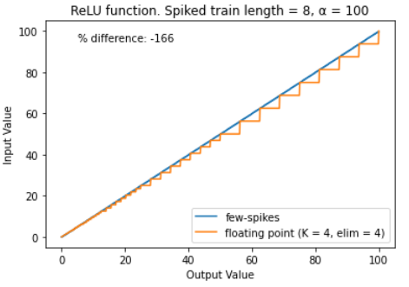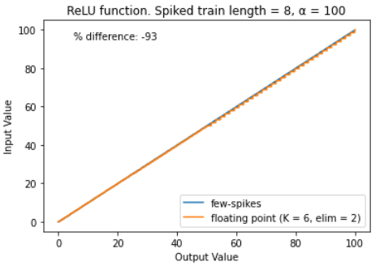

c d

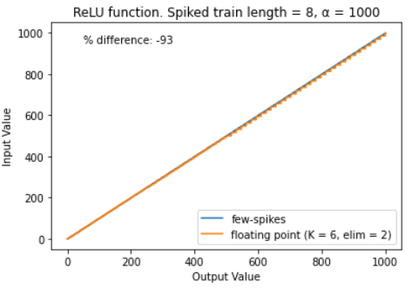 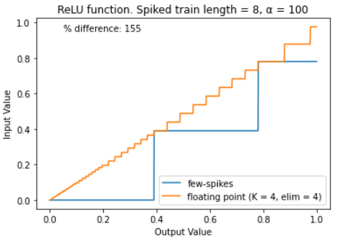

Figure 1: Comparing results of different parameters on Floating Point (FP) with FS  
*a) FP having K = 4 and elim = 4, resulting in deteriorating performance with larger values   
b) FP having K = 6 and elim = 2 producing significantly better results but still not an improvement over FS  
c) Testing the difference on value range, expectedly with no difference in % diff  
d) FP performs better when representing smaller values with a relatively large alpha.*